Name:Mohammed Misbahuldin .K
Reg no :1965260109

Date:

EXPERIMENT-11
CONFIGURATIONOFASIMPLESTATICROUTINGINPACKETTRACER USING A SIMPLE TOPOLOGY WITH TWO ROUTERS

Aim:ToConfigurearouterusingpackettracersoftwareandhencetotransmitdata between the devices in real time mode and simulation mode.
Software/Apparatusrequired:PacketTracer/Enddevices,Hubs,connectors.
Procedure:
Stepsforbuildingtopology:
Step1:StartPacketTracer
Step2:ChoosingDevicesandConnections Step 3:Single click on the End Devices.
SingleclickontheGenericHost. PlacePC0,PC1ontopologyarea. Connect PCs to Switch 1.
SimilarlyPlacePC2,PC3ontopologyareaforreceiverside
ConnectthesePCswithswitch1and2respectivelythroughconnectingwires. Select Router and place the router between two switches.
Connecttheseswitchesintorouterthroughconnecting wires.
Step3:ConfiguringIPAddresses,GateWayandSubnetMasksontheHosts
TostartcommunicationbetweenthehostsIPAddresses,subnetMasksandGatewayhad to be configured on the devices. Click once on PCs. Choose the Config tab and click on FastEthernet0. Type the IP address in its field. Based on router create gate way click on the subnet mask. It will be generated automatically.
Step4:VerifyingConnectivityinRealtimeMode
Besureyou areinReal timemode.
SelecttheAddSimplePDUtoolusedtopingdevices. Click once on PC0, then once on PC3.
ThePDULastStatusshouldshow as Successful.
Step5:VerifyingConnectivityinSimulationMode
Besureyou areinSimulationmode.

Deselect all filters (All/None) and select only ICMP. Select the Add Simple PDU tool used to ping devices Click once on PC0, then once on PC3.
Continueclicking Capture/Forward button until the ICMP ping is completed.TheICMP messages move between the hosts, hub and switch.The PDU Last Status should show as Successful.

Output:

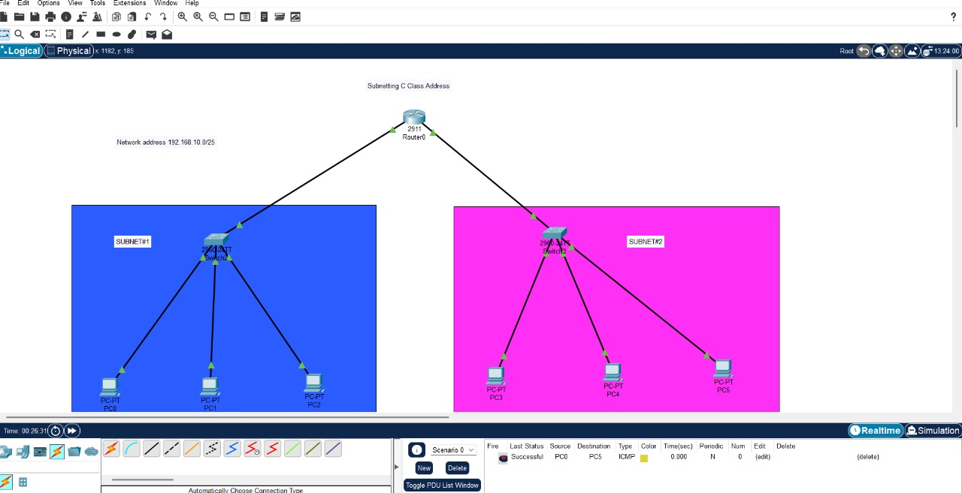

Result:Thus Configuration of a simple static routing in packet tracer using a simple topology with two routers was done successfully.

Date:

EXPERIMENT-12
DESIGNTHEFUNCTIONALITIESANDEXPLORATIONOFTCPUSING PACKET TRACER

Aim: To design the Functionalities and Exploration of TCP using Packet Tracer. Software/Apparatusrequired:PacketTracer/Enddevices,Hubs,connectors. Procedure:
Step1:Setupthenetwork topology
Tobegin,wewillcreateasimplenetworktopologyconsistingoftwocomputersconnected byarouter.OpenPacketTraceranddragtwoPCsandarouterontotheworkspace.Connect the two PCs to the router using Ethernet cables.
Step2:Configure IP addresses
Next, we will configure IP addresses for the computers. Double-click on each PC to open the configuration window and navigate to the Desktop tab. Click on the IP Configuration icon and enter the IP address and subnet mask for each computer. For example, PC1 can have an IP address of192.168.1.1withasubnetmaskof 255.255.255.0 andPC2can have an IP address of 192.168.1.2 with the same subnet mask.
Step3:Configurethe router
Now, we will configure the router. Double-click on the router to open the configuration window and navigate to the CLI tab.
COMMANDS:
enable
configure terminal interfaceFastEthernet0/0
ipaddress192.168.1.254255.255.255.0
noshutdown exit

exit
Step4:Testtheconnection
Nowthatthenetworkissetupandconfigured,wecantesttheconnectionbetweenthetwo computers. Open a command prompt on PC1 and ping PC2 by typing ping 192.168.1.2 in the command prompt. If the ping is successful, it means that the two computers are communicating with each other.
Step5:ExploreTCPfunctionalities
Now, let's explore the functionalities of TCP. We will use the Netcat utility to establish a TCPconnectionbetweenthetwocomputers.Netcatis aversatilenetworkingtoolthatcan be used for various purposes, including establishing TCP connections.
Output:

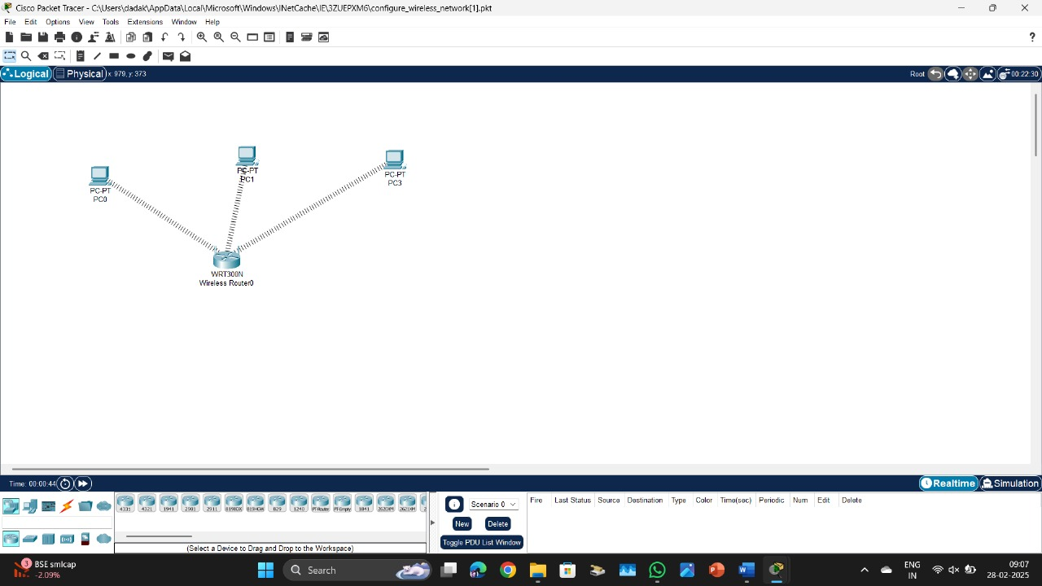

Result:ThustheFunctionalitiesandExplorationofTCPusingPacketTracerisdesignedsuccessfully.

Date:

EXPERIMENT-13
DESIGNTHENETWORKMODELFORSUBNETTING–CLASSCADDRESSING USING PACKET TRACER

AIM:Todesign thenetworkmodel forsubnetting-classC addressingusingpacket tracer.
Software/Apparatusrequired:PacketTracer/Enddevices,Hubs,connectors.
Algorithm:
- Determine the network requirements: Identify the number of subnets and hosts required for each subnet.
- Choose a subnet mask: Select a subnet mask that can accommodate the required number of subnets and hosts.
- Calculate the subnet mask and prefix length: Use the formula 2^p - 2 >= n, where p is the number of host bits and n is the required number of hosts per subnet, to calculate the number of host bits required. Add these host bits to the Class C network address to create the subnet address. The remaining bits in the subnet mask will be the prefix length.
- Configuretherouter: Configuretherouter interfacewith thesubnetaddress andsubnet mask.
- Configurethehosts:ConfigureeachhostwithanIPaddressandsubnetmaskthatmatchesthe subnet address and subnet mask used on the router interface.
- Test the network: Verify that the hosts can communicate with each other and with devices on other subnets.
- Monitornetworktraffic:UsePacketTracer'sbuilt-innetworkmonitoringtoolstomonitor network traffic and identify any potential issue.

Procedure:
STEP1:Clickonenddevices,selectgenericPc’sdraganddropitonthewindow.ClickonSWITCH drag and drop it on the window.
STEP 2: Select thestraight throughcableand connect all end deviceto switch.Assign the IP address for all end devices. (Double click the end device Select →desktop → IP configuration static
STEP 3: Now set the IP address to Host A (192.168.1.1) in static mode. Similarly set IP address for Host B (192.168.1.2) and Host C (192.168.1.3)
STEP4:ToviewtheIP address,giveipconfigcommandincommandprompt.Usingpingcommand, we can establish communication between two host devices.

STEP6: Now display the packet transmission in simulation mode.

Output:

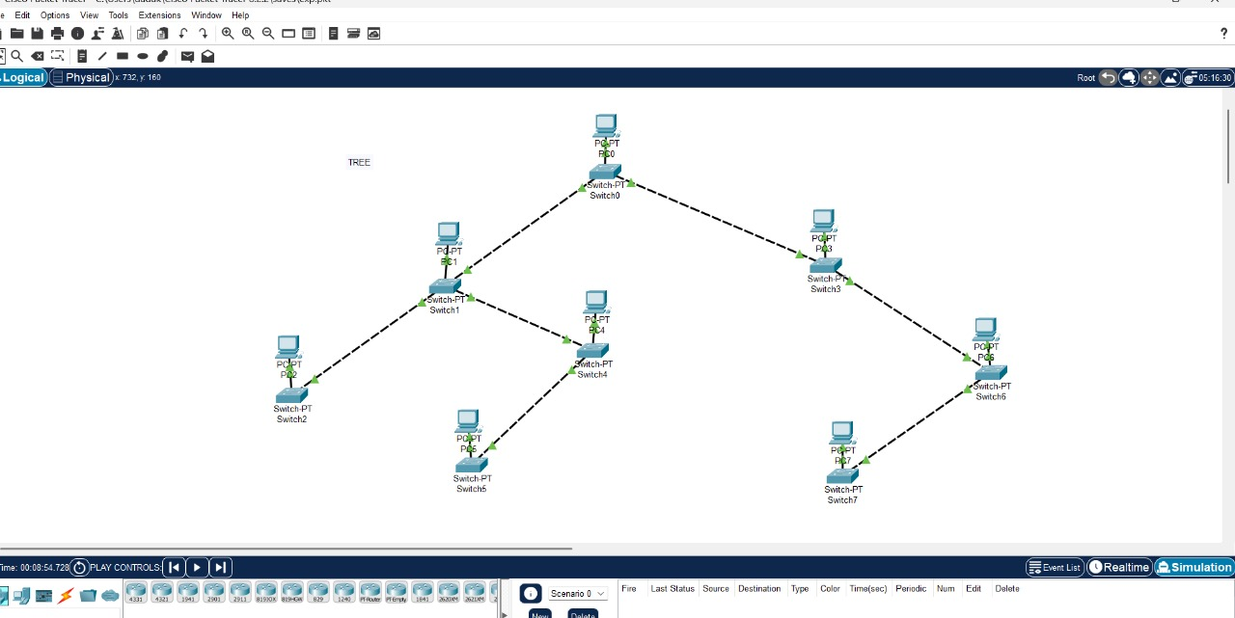

Result:
There for designing for network model subnetting has been successfully implemented using packettracer.

Date:

EXPERIMENT:14
SIMULATINGX,Y,ZCOMPANYNETWORKDESIGNANDSIMULATEUSING PACKET TRACER

Aim:To simulate X,Y,Zcompany network design and stimulate using packet tracer.
Software/Apparatusrequired:PacketTracer/Enddevices,Hubs,connectors.
Algorithm:
- Identify the network requirements: Determine the number of users, devices, and servers that will be connected to the network.
- Create a network diagram: Use a network diagramming tool to create a visual representation of the network design, including the devices, servers, switches, routers, and connections.
- Configuretherouters:ConfiguretherouterswithIPaddresses,subnetmasks,androuting protocols as needed.
- Configuretheswitches:ConfiguretheswitcheswithVLANs,andassignportstoeachVLAN.
- Configuretheservers:ConfiguretheserverswithIPaddresses,subnetmasks,andanynecessary applications or services.
- Configure the workstations: Configure the workstations with IP addresses, subnet masks, and any necessary applications or services.
- Configure security: Configure security measures such as firewalls, access control lists, andintrusion detection systems as needed.
- Testthenetwork:Testthenetworkconnectivitybypingingdevicesandverifyingthatdatacan be transmitted between them.
- Monitornetworktraffic:UsePacketTracer'sbuilt-innetworkmonitoringtoolstomonitor network traffic and identify any potential issues.
- Makeadjustmentsasneeded:Makeadjustmentstothenetworkconfigurationasneededto improve performance, security, or functionality.
Procedure:
- StartPacketTracer:LaunchPacketTraceronyour computer.
- Createanewproject:Clickon"File"andselect"New",thenselect"Network"fromtheoptions.
- Adddevices:Clickonthe"Devices"tabinthebottom-leftcornerofthewindow,anddragand drop devices onto the workspace. Add devices such as routers, switches, servers, and workstations.
- Connectdevices:Usethe"Cable"tooltoconnectthedevicestogether.Configurethe connections as needed.

- Configuredevices:Double-clickoneachdevicetoopenitsconfigurationmenu,andconfigure its settings such as IP address, subnet mask, and routing protocols. Configuresecurity measures such as firewalls, access control lists, and intrusion detection systems as needed.
- Addapplications:Clickonthe"Applications"tabinthebottom-leftcornerofthewindow,and drag and drop applications onto the workstations and servers. Configure the applications as needed.
- Testthenetwork:UsePacketTracer'sbuilt-intestingtoolstoverifythatthenetworkisworking correctly.Testthenetworkconnectivitybypingingdevicesandverifyingthatdatacanbetransmitted between them.
- Monitor network traffic: Use Packet Tracer's built-in network monitoring tools to monitor network traffic and identify any potential issues.
- Make adjustments as needed: Make adjustments to the network configuration as needed to improve performance, security, or functionality.
- Savetheproject:Click on"File"andselect "Save"tosavethe project.

Output:
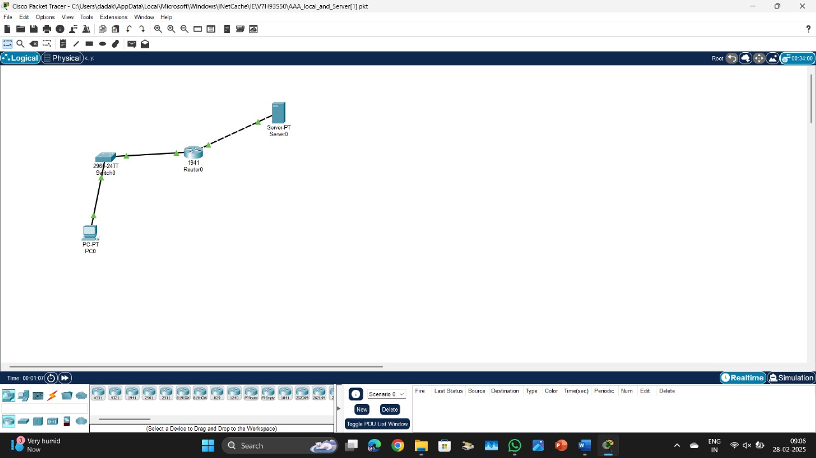

Result:Thereforestimulatingofcompaniesnetworkdesigninghasbeensuccessfullydoneusing packet tracer.

Date:

EXPERIMENT:15
CONFIGURATION OF DHCP(DYNAMICHOSTCONFIGURATIONPROTOCOL)IN PACKET TRACER

Aim:ToconfigureDHCP(dynamichost configuration protocol)inpacket tracer.
Software/Apparatusrequired:PacketTracer/Enddevices,Hubs,connectors.
Algorithm:
- Start:
  - SetupthenetworktopologyinPacketTracerwithaDHCPserverandDHCPclientsconnected to a switch.
- ConfiguretheDHCP server:
  - Assignan IPaddresstotheserver interface.
  - EnabletheDHCP serviceonthe server.
  - Definethe IP addresspool rangethattheserver canassigntoclients.
  - SpecifyadditionalDHCPoptionslikedefaultgateway,DNSserver,andsubnetmask.
- Configurethe switch.
  - Enabletheswitchinterfaces thatconnect tothe DHCP clients.
- ConfiguretheDHCP clients.
  - Configuretheclientstoobtaintheir IPaddresses automaticallyusingDHCP.
  - Verifythatthe clientsare settouseDHCPasthepreferredmethodfor IPassignment.
- Clientrequestandserver response:
  - WhenaDHCPclientbootsuporitsleaseexpires,itsendsaDHCPdiscovermessageasa broadcast on the local network.
  - The DHCP server receives the discover message and responds with a DHCP offer messagecontaining an available IP address from the configured IP address pool.
  - Theserverincludesother networkconfigurationparametersintheoffer message.
- Clientselectionandrequest:
  - Theclientreceivesmultipleoffermessages fromdifferentDHCPserversifavailable.
  - TheclientselectsoneofferandsendsaDHCPrequestmessagetothechosenserver,requesting the offered IP address and confirming other network parameters.
- Serveracknowledgement:
  - TheDHCPserverreceivestherequestmessageandsendsaDHCPacknowledge(ACK) messagetotheclient,confirmingtheIPaddressassignmentandprovidingadditionalnetwork

configurationdetails.
- Clientconfiguration:
  - TheclientreceivestheACKmessageandconfiguresitsnetworkinterfacewiththeassignedIP address,subnetmask,defaultgateway,DNSserver,andanyotherparametersprovidedbytheDHCP server.
- Leaserenewalandexpiration:
  - TheclientperiodicallycontactstheDHCPservertorenewitsleasebefore it expires.
  - If the client doesn't renew the lease or is unable to contact the DHCP server, the IP addresslease eventually expires, and the IP address returns to the pool for future assignment.
- End:
Procedure:
- LaunchCiscoPacketTracerandcreate anew networktopologyoropenanexisting one.
- Add the necessary network devices to your topology, including a DHCP server, switch, and DHCP clients. Connect them using appropriate cables.
- ConfiguretheDHCP server:
  - SelecttheDHCPserver deviceandopenitsconfiguration panel.
  - Assignan IPaddresstotheserverinterface connectedtothe switch.
  - EnabletheDHCP serviceonthe serverbychecking the"DHCP" option.
  - Define the IP address pool range that the server can assign to clients. Specify the starting and ending IP addresses.
  - Optionally,setotherDHCPoptionslikedefaultgateway,DNSserver,andsubnetmask.
  - Savethe configuration.
- Configurethe switch:
  - Selecttheswitchdevice andopenitsconfiguration panel.
  - EnabletheinterfacesthatconnecttotheDHCPclients.Thisallowstheclientstocommunicate with the DHCP server.
  - Savethe configuration.
- ConfiguretheDHCP clients:
  - SelecteachDHCPclientdeviceandopenitsconfigurationpanel.
  - SettheIPaddressassignmentmethodto"DHCP"or"Obtainan IPaddressautomatically."
  - Savetheconfigurationforeachclient.
- Startthe simulation:
  - Clickthe"Start/StopSimulation"buttontostartthe simulation.
- VerifyDHCP operation:

  - WaitfortheDHCPclientstobootuporrefreshtheir IP configurations.
  - CheckiftheDHCPclientsreceiveIPaddressesfromtheDHCPserver.
  - Verify that the clients have the correctIP address, subnet mask, default gateway, and DNSserver settings.

Output:

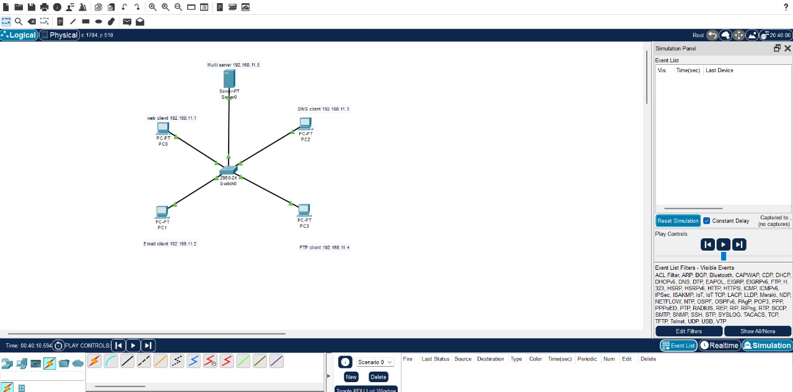

Result:Therefore the configuration for DHCP has been successfully executed using packet tracer.

Date:

EXPERIMENT-16CONFIGURATIONOFFIREWALLINPACKETTRACER

Aim:Toconfigurefirewallinpackettracer.
Software/Apparatusrequired:PacketTracer/Enddevices,Hubs,connectors.
Procedure:
Step1: Set upthenetworktopology
Tobegin,wewillcreateasimplenetworktopologyconsistingofthreecomputers,arouter,and afirewall.OpenPacketTraceranddragthreePCs,arouter,andafirewallontotheworkspace. ConnectthethreePCstotherouterusingEthernetcables,andconnectthefirewalltotherouter using another Ethernet cable.
Step2:ConfigureIPaddresses
Next, we will configure IP addresses for the computers. Double-click on each PC to open the configuration windowand navigateto theDesktop tab.Click on theIP Configuration iconand enter the IP address and subnet mask for each computer. For example, PC1 can have an IP address of 192.168.1.1 with a subnet mask of 255.255.255.0, PC2 can have an IP address of 192.168.1.2 with the same subnet mask, and PC3 can have an IP address of 192.168.1.3 with the same subnet mask
Step3: Configurethe router
Now,wewillconfiguretherouter.Double-clickontheroutertoopentheconfigurationwindow and navigate to the CLI tab. Enter the following commands:
Commands:
enable
configure terminal interfaceFastEthernet0/0
ipaddress192.168.1.254255.255.255.0
noshutdown exit

Step4: Configurethe firewall
Now, we will configure the firewall. Double-click on the firewall to open the configuration window
Step5: Testtheconnection
Nowthatthefirewallisconfigured,wecantesttheconnectionbetweenthecomputers.Open a command prompt on PC1 and ping PC2 and PC3 by typing ping 192.168.1.2 and ping 192.168.1.3inthecommandprompt.Ifthepingsaresuccessful,itmeansthatthecomputersare communicating with each other.
Step6: Testthefirewall
To test the firewall, try to connect to PC1 from the internet using a protocol or port that is not allowedbytheaccessrule.Forexample,youcantrytoconnecttoPC1usingTelnetonport23.

Output:

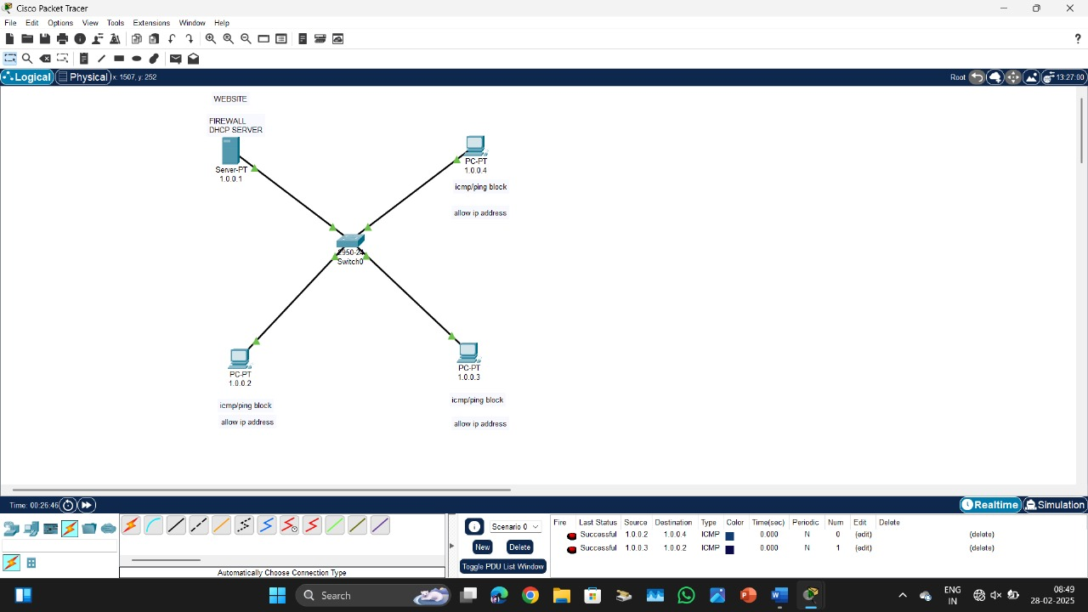

Result:Hencetheconfigurationof firewallinpackettraceris successful.

Date:

EXPERIMENT-17
MAKEACOMPUTERLABTOTRANSFERAMESSAGEFROMONENODETO ANOTHER TO DESIGN AND SIMULATE USING CISCO PACKET TRACER

Aim: To make a Computer Lab to transfer a message from one node to another to design and simulate using Cisco Packet Tracer.
Software/Apparatusrequired:PacketTracer/Enddevices,Hubs,connectors.
Procedure:
Step1:Create thenetwork topology
First, we need to create the network topology for the computer lab. In Packet Tracer, drag two computers,aswitch,and two routersonto theworkspace. Connect thecomputersto theswitch using Ethernet cables, and connect the switch to the two routers using Ethernet cables. The network should look like this:
CODE:
PC1 PC2
| |
Switch-----Router1 Router2
Step2:ConfigureIPaddresses
Next, we will configure IP addresses for the computers. Double-click on each PC to open the configuration windowand navigateto theDesktop tab.Click on theIP Configuration iconand enter the IP address and subnet mask for each computer. For example, PC1 can have an IP address of 192.168.1.1 with a subnet mask of 255.255.255.0, and PC2 can have an IP address of 192.168.1.2 with the same subnet mask.
Step3: Configurethe routers
Now,wewillconfiguretherouters.Double-clickonRouter1toopentheconfigurationwindow and navigate to the CLI tab. Enter the following commands:
COMMANDS:
enable

configure terminal interfaceFastEthernet0/0
ipaddress192.168.1.254255.255.255.0
no shutdown interfaceSerial0/0/0
ipaddress10.0.0.1255.255.255.252
noshutdown exit
Now,double-clickonRouter2toopentheconfigurationwindowandnavigatetotheCLItab.
Enterthefollowingcommands enable
configure terminal interfaceSerial0/0/0
ipaddress10.0.0.2255.255.255.252
no shutdown
interfaceFastEthernet0/0
ipaddress192.168.2.254255.255.255.0
noshutdown exit
Step4: Configurerouting
Weneedtoconfigureroutingbetweentherouterssothattheycancommunicatewitheachother. Enter the following commands on Router1:
enable
configureterminal
iproute 192.168.2.0 255.255.255.0 10.0.0.2
exit
ThesecommandswillconfigureastaticrouteonRouter1toreachthe192.168.2.0/24network, which is connected to Router2's Fast Ethernet interface.

enable
configureterminal
iproute 192.168.1.0 255.255.255.0 10.0.0.1
exit
Step5: Send amessage
TosendamessagefromPC1toPC2,openthecommandpromptonPC1andtype: ping 192.168.1.2
Output:

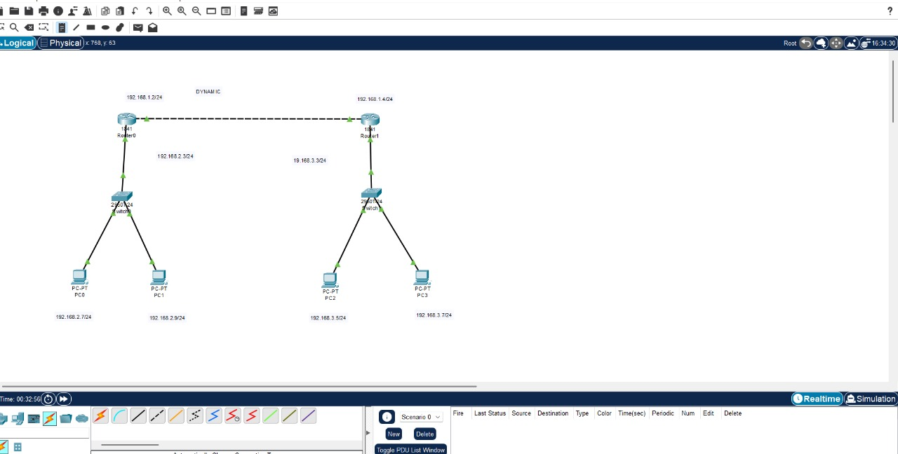

Result:Hencethemessageistransferredfromonenodetoanothertodesignandsimulateusing Cisco Packet Tracer successfully .

Date:

EXPERIMENT-18
SIMULATEAMULTIMEDIANETWORKINCISCOPACKETTRACER

Aim:TosimulateaMultimediaNetworkinCiscoPacketTracer.
Software/Apparatusrequired:PacketTracer/Enddevices,Hubs,connectors.
Algorithm:
Procedure:
Step1:LaunchCiscoPacketTracerandcreate a newproject.
Step2:Selecttheappropriatenetworkdevicesforyourmultimedianetwork.Youwillneedcomputers, switches, routers, and multimedia devices such as IP phones and IP cameras. You can find these devices in the "End Devices," "Switches," "Routers," "Phones," and "IP Cameras" sections of the device list.
Step 3: Design the network topology. Determine the layout of your network and the connections betweendevices.Forexample,youcanconnectthecomputers,IPphones,andIPcamerastoaswitch, and then connect the switch to a router for internet connectivity.
Step 4: Drag and drop the devices onto the workspace area. Connect the devices using appropriate cablesorwirelessconnections.Forexample,useEthernetcablestoconnectcomputersandIPphones to the switch.
Step 5: Configure IP addresses on the devices. Assign IP addresses, subnet masks, and default gateways to the computers, IP phones, and IP cameras. Configure the router's interface with an IP address provided by your ISP or use a DHCP server if available.
Step 6: Set up multimedia services. Configurethe necessary services formultimedia communication, suchasVoIP(VoiceoverIP)forIPphonesandstreamingprotocolsforIPcameras.Thismayinvolve configuring protocols like SIP (Session Initiation Protocol) for IP phones or RTSP (Real-Time Streaming Protocol) for IP cameras.
Step7: Test connectivity and multimedia services. Verify that devices can communicate with each other and multimedia services are functioning correctly. For example, try making a call between IP phones or access the video feed from IP cameras.
Step8:Monitorandtroubleshoot.UsethenetworkmonitoringtoolsinCiscoPacketTracertoobserve networktrafficandperformance.Troubleshootanyissuesthatarise,suchasconnectivityproblemsor audio/video quality degradation.
Step9:Documentthelabexperiment.Recordobservations,configurations,andanyissuesencountered

duringthesimulation. This documentation will help to analyze theresults and make improvements if necessary.
Remember to save your project regularly to preserve your progress. Cisco Packet Tracer provides a simulated environment to experiment with multimedia networks, allowing you to understand the challenges and requirements of such networks in a virtual setting.

Output:

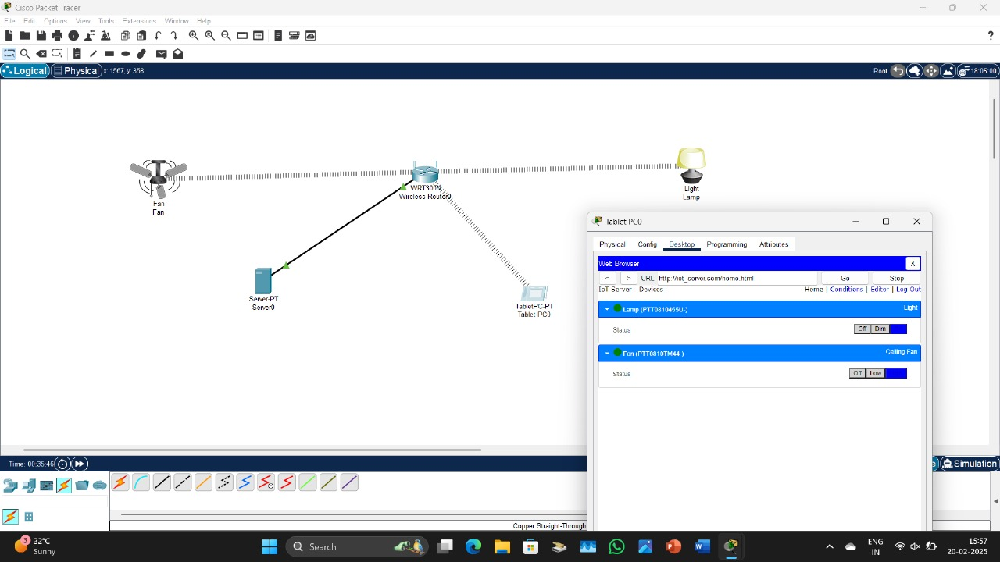

Result:ThusaMultimediaNetworkinCiscoPacketTracerissimulated successfully.

Date:

EXPERIMENT-19
IOTBASED SMARTHOMEAPPLICATIONS

Aim:ToimplementIoT basedsmarthomeapplicationsinCiscoPacketTracer.
Software/Apparatusrequired:PacketTracer/Enddevices,Hubs,connectors.
Procedure:
Steps:
- Create a network topology in Cisco Packet Tracer that includes IoT devices such as sensors, actuators, and gateways.
- Configurethe IoTdeviceswithappropriate IPaddresses,subnetmasks,andgatewayaddresses.
- Set up a communication protocol between the IoT devices using MQTT, CoAP, or any other protocol of your choice.
- Writeacodeto collectdata from thesensors andsend itto thegateway.
- Usethegateway toprocess thedataand sendcommands tothe actuators.
- Finally,useawebinterfaceormobileapplicationtomonitor andcontrolthe IoT devices.
ByfollowingthesestepsanIoT-basedsmartapplicationinCiscoPacketTracer ,canbecreated.This canbeusedforvariousapplicationssuchashomeautomation,smartcities,andindustrial automation.

Output:

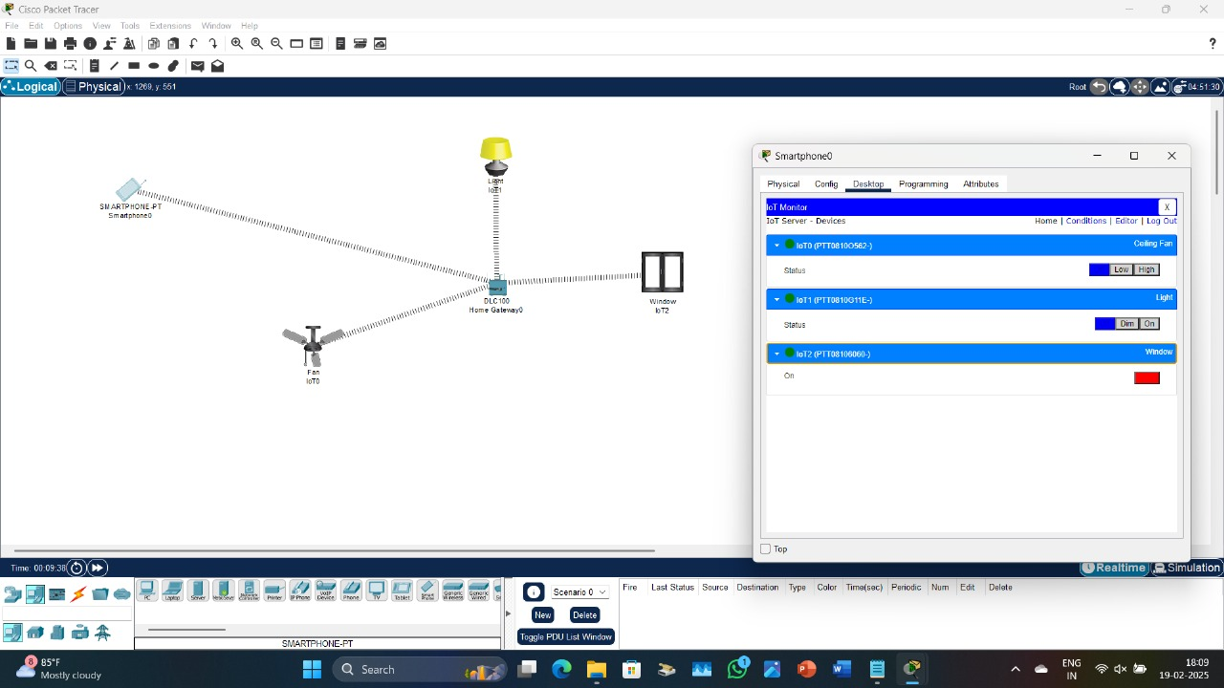

Result:ThusIoTbasedsmarthomeapplications inCiscoPacketTracerisimplementedsuccessfully.

Date:

EXPERIMENT: 20 IMPLEMENTATIONOFIOTBASEDSMARTGARDENING

Aim:ToimplementIOT basedsmartgardening using Ciscopackettracer.
Software/Apparatusrequired:PacketTracer/Enddevices,Hubs,Connectors.
Procedure:
Step1:CreateanewprojectinCiscoPacketTraceranddragagenericIoTdevicefromtheIoTdevices section onto the workspace.
Step2:Right-clickonthe IoTdeviceandselectConfig/Attributes.
Step3:IntheConfigurationtab,selectthedevice'sIoTserverfromthedrop-downlist.Youcanchoose Cisco IoT Cloud or another cloud service of your choice.
Step4:IntheAttributestab,addthefollowing attributes:
- Temperature
- Humidity
- Soil Moisture
- Light Intensity
Step5:Create a soilmoisture sensor andalightsensor fromthe Sensorssectionof the devicespanel.
Dragand dropthesesensorsonto the workspace.
Step6:Connectthesensorstothe IoT deviceusingthewiring tool.
Step7:Configurethesensorsbyright-clickingonthemandselectingConfig/Attributes.Setthesensor type, unit of measurement, and other necessary parameters.
Step8:CreateawaterpumpandalightbulbfromtheActuatorssectionofthedevicespanel.Dragand drop these actuators onto the workspace.
Step9: Connecttheactuatorsto theIoT deviceusing thewiring tool.
Step 10: Configure the actuators by right-clicking on them and selecting Config/Attributes. Set theactuator type, command, and other necessary parameters.
Step11:Savetheconfiguration andrunthesimulationto testyourIoTSmart Garden.
Step12:Monitorthetemperature,humidity,soilmoisture,andlightintensityreadingsontheIoT device dashboard.
Step13: Usethe dashboardto control thewater pumpand light bulbbased onthe sensor readings.

Output:

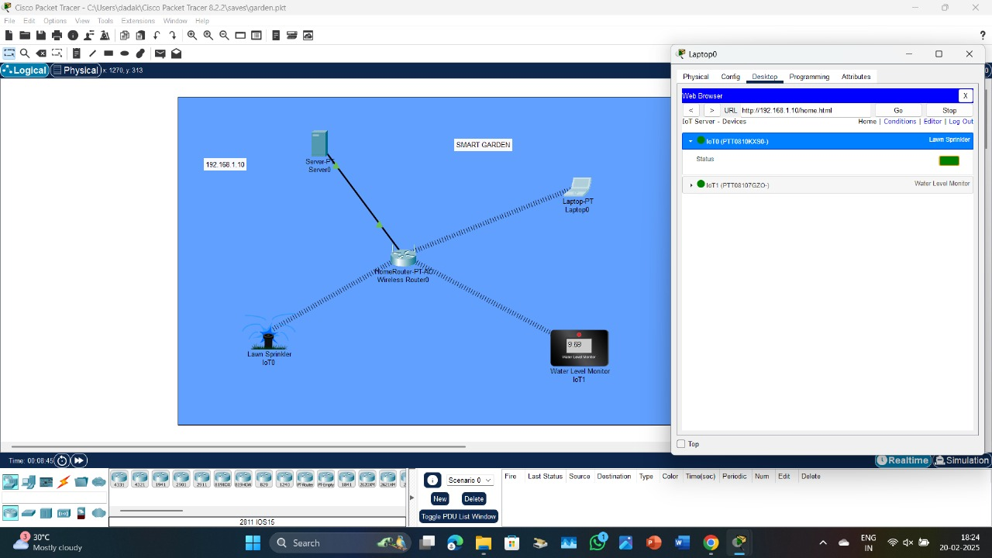

Result: Implementation ofsmartgardeningiscarriedoutusingIOTsuccessfully.

Date:

EXPERIMENT: 21 IMPLEMENTATIONOFIOTDEVICESINNETWORKING

Aim: To implement an IOT devices in networking using Cisco Packet Tracer. Software/Apparatusrequired:PacketTracer/Enddevices,Hubs,connectors. Procedure:
Steps:
- OpenCiscoPacketTracerandcreateanewproject.
Draganddroparouterfrom the"Devices"panel ontotheworkspacearea.
- Connect the router to the Internet by dragging and dropping a "Cloud" device from the "Devices"panelontotheworkspacearea,andthenconnectingtheroutertothecloudusinga straight-through cable.
- Add an IoT device to the network by dragging and dropping a device from the "Devices" panelontotheworkspacearea.TherearevariousIoTdevicesavailableinthe"Devices"panel, such as a Raspberry Pi or an Arduino.
- Connect the IoT device to the router using an Ethernet cable. To do this, click on the IoT device and then click on the "Config" tab. Under the "Interfaces" section, select the Ethernet interface and then click on the "+" button to add a new interface. Connect the new interface to the router.
- Configure the IoT device by clicking on it and then clicking on the "CLI" tab. This will bringupthecommandlineinterfaceforthe IoTdevice,whereyoucanconfigureits settings.
- TesttheconnectivityoftheIoTdevicebypingingitfromtherouterorfromanotherdevice on the network.
- These are just general steps and the specifics of the implementation will depend on the specificIoTdeviceandnetworkconfigurationyouwanttocreate.Additionally,youmayneed toconfiguretherouterandtheclouddevicetoenableInternetconnectivityfortheIoTdevice.

Output:
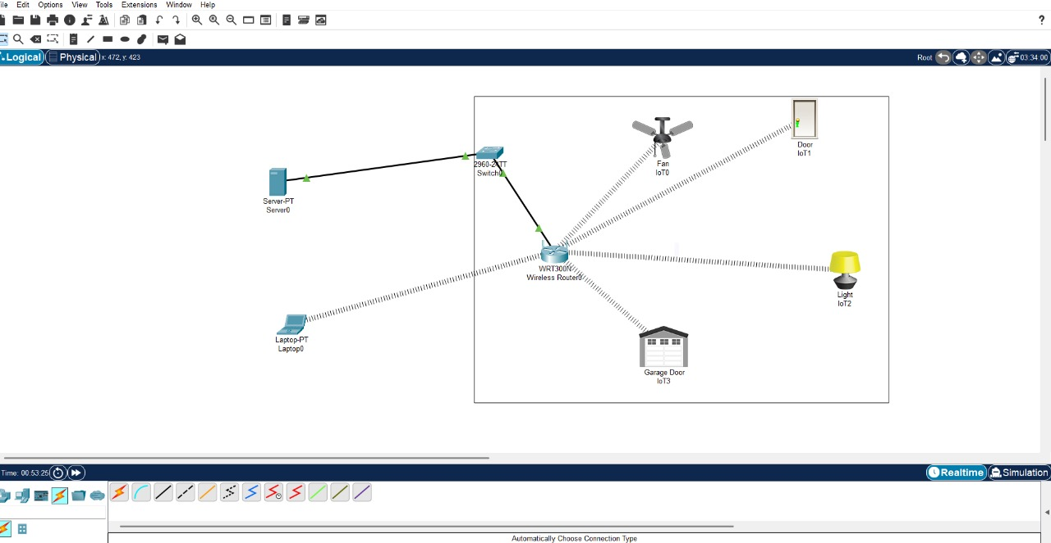

Result: Thus an IOT device in networking is implemented using Cisco Packet Tracer successfully.

Date:

EXPERIMENT:22
IoTbasedAAALocalandServerbasedauthenticationconfiguration

Aim:DesigninganIoT basedAAALocalandServerbasedauthenticationconfiguration.
Software/Apparatusrequired:PacketTracer/Enddevices,Hubs,connectors.
Procedure:
Algorithm:
- DefinetheComponents:
IoT Devices: These are the devices that need to be authenticated and authorized to access thenetwork resources.
LocalAAAServer:This serverwillhandleauthenticationandauthorization requestslocally.
Central AAA Server: This server will provide an additional layer of authentication and authorization for higher-level access control.
- SetupLocalAAAServer:
Configure the local AAA server with the necessary software and databases to handle authentication and authorization requests.
Defineuserprofiles orroles andtheirassociated permissions onthe localAAAserver.
Setupasecurecommunicationchannelbetweenthe IoTdevicesandthelocalAAAserver.
- ImplementLocalAuthentication:
When an IoT device wants to connect to the network, it sends an authentication requesttothelocal AAA server.
ThelocalAAA serververifiesthecredentialsprovidedby the IoTdeviceagainst itsuser database.
Ifthecredentialsarevalid,thelocalAAAservergeneratesanauthenticationtokenorsessionkeyand sends it back to the IoT device.
- ImplementLocalAuthorization:
Onceauthenticated,the IoTdevicesendsanauthorizationrequesttothelocalAAAserver.
The local AAA server checks the user profile or role associated with the IoT device and verifies if it has the necessary permissions to access the requested resources.
Ifauthorized,thelocalAAAserversendsanauthorizationresponsetothe IoTdevice.
- ConfigureCentralAAAServer:
Set up a central AAA server that will provide an additional layer of authentication and authorization for critical resources or higher-level access control.

ConfigurethecentralAAAserverwithuserprofilesorrolesandassociated permissions.
- ImplementServerAuthentication:
Afterlocalauthentication,theIoTdeviceestablishesasecureconnectionwiththecentralAAAserver. TheIoTdevicesendsitsauthenticationtokenorsessionkeytothecentralAAAserverforverification. ThecentralAAAservervalidatestheauthenticationtokenorsessionkeyreceivedfromtheIoTdevice.
- ImplementServerAuthorization:
Once the central AAA server verifies the authentication token or session key, it performs additional authorization checks.
The central AAA server ensures that the IoT device has the necessary permissions to access critical resources or perform higher-level operations.
Ifauthorized,thecentralAAAserversends anauthorizationresponsetothe IoTdevice.
- Logging and Accounting:
Both the local and central AAA servers maintain logs of authentication and authorization events for auditing and accounting purposes.
Theyrecordinformationsuchasuser/deviceidentification,timestamps,andactionstaken.
- Revocationand Updates:
Implement mechanisms to handle credential revocation, such as disabling user accounts or tokens when necessary.
Regularly update user profiles, roles, and permissions in both the local and central AAA servers to reflect changes in the network environment.
Remember to implement appropriate security measures such as encryption, secure communication protocols,andstrongpasswordpoliciestoensuretheintegrityandconfidentialityoftheauthentication process.
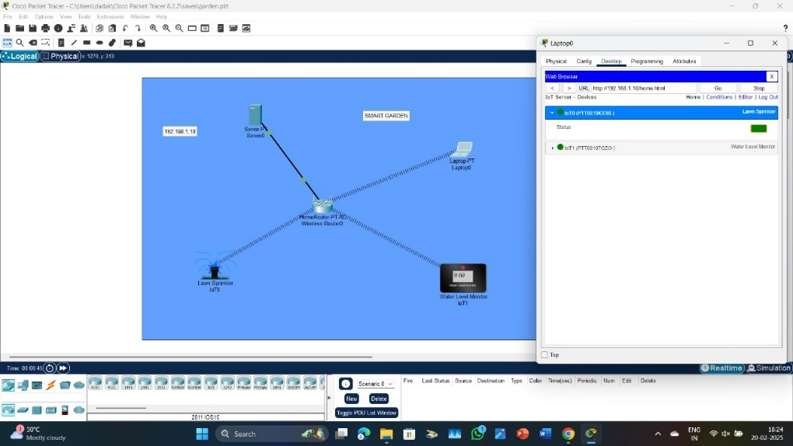
Output:

Result:IoTbasedAAA LocalandServerbasedauthenticationisdesignedsuccessfully.

Date:

EXPERIMENT:23
TRANSPORTLAYERPROTOCOLHEADERANALYSISUSINGWIRESHARK-TCP AND UDP
Aim: To analyze capturing of Transport layer protocol header analysis using Wire shark- TCP andUDP.

SOFTWAREUSED:
Wiresharknetwork analyzer
Procedure:
- Openwire shark.
- Clickonlisttheavailablecaptureinterface.
- Choosethe LANinterface.
- Clickonstart button.
- Activepacketswillbe displayed.
- Capturethepackets&selectany IPaddressfromthesource.
- ClickontheexpressionandselectIPV4 →IPaddr sourceaddressinthefield name.
- Selectthedoubleequals(==) fromtheselectionandentertheselected IPsource address.
- Clickonapply button.
- Allthepacketswillbefilteredusingsource address.

Result:Hence,thecapturingofpacketsusingwiresharknetworkanalyzerwasanalyzedforTCPand UDP.

Date:

EXPERIMENT-24
NETWORKLAYERPROTOCOLHEADERANALYSISUSINGWIRESHARK– SMTPAND ICMP
Aim: To analyze capturing of Transport layer protocol header analysis using Wire shark- SMTP and ICMP.

SOFTWAREUSED:
Wiresharknetwork analyzer
Procedure:
- Openwire shark.
- Clickonlisttheavailablecaptureinterface.
- Choosethe LANinterface.
- Clickonstart button.
- Activepacketswillbe displayed.
- Capturethepackets&selectany IPaddressfromthesource.
- ClickontheexpressionandselectIPV4 →IPaddr sourceaddressinthefieldname.
- Selectthedoubleequals(==) fromtheselectionandentertheselected IPsource address.
- Clickonapply button.
- Allthepacketswillbefilteredusingsource address.

Result: Hence, the capturing of packets using wire shark network analyzer was analyzed for SMTP and ICMP.

Date:

EXPERIMENT-25
NETWORKLAYERPROTOCOLHEADERANALYSISUSINGWIRESHARK–ARPAND HTTP

AIM:To analyze capturing of Transport layer protocol header analysis using Wire shark- ARP and HTTP.

SOFTWAREUSED:
Wiresharknetwork analyzer

PROCEDURE:
- Openwire shark.
- Clickonlisttheavailablecapture interface.
- Choosethe LANinterface.
- Clickonstart button.
- Activepacketswillbe displayed.
- Capturethepackets&selectany IPaddressfromthesource.
- ClickontheexpressionandselectIPV4 →IPaddr sourceaddressinthefieldname.
- Selectthedoubleequals(==) fromtheselectionandentertheselected IPsource address.
- Clickonapply button.
- Allthepacketswillbefilteredusingsource address.

Result:Hence,thecapturingofpacketsusingwiresharknetworkanalyzerwasanalyzedforARPand HTTP.

Date:

EXPERIMENT:26
TOIMPLEMENTDATEANDTIMEDISPLAYFROMCLIENTTOSERVERUSINGTCP SOCKETS IN JAVA/C

Aim:Toimplement dateandtime displayfrom clienttoserver usingTCPSockets.
Algorithm:
Server
- Createaserversocketandbinditto port.
- Listenfornew connectionandwhena connectionarrives,acceptit.
- Sendserver‟sdate andtimetothe client.
- Readclient‟sIPaddresssentbythe client.
- Displaytheclientdetails.
- Repeatsteps2-5until theserveris terminated.
- Closeallstreams.
- Closetheserversocket.
- Stop.
Client
- Createaclientsocketandconnectittotheserver‟sportnumber.
- Retrieveitsown IP addressusingbuilt-in function.
- Senditsaddresstothe server.
- Displaythedate &timesent bytheserver.
- Closetheinput and output streams.
- Closetheclient socket.
- Stop.

Result:Thusdate andtimeisdisplayed fromclienttoserverusingTCP Socketssuccessfully.

Date:

EXPERIMENT:27
IMPLEMENTATIONOFADNSSERVERANDCLIENTINJAVA/CUSINGUDP SOCKET

Aim:Toimplement aDNS server andclient injavausingUDP socket
Algorithm:
Server
- Createan arrayofhostsanditsIPaddressinanother array
- Createadatagram socketand bind itto a port
- Createadatagrampackettoreceiveclientrequest
- Readthedomain name fromclient tobe resolved
- Lookupthehostarrayforthedomain name
- Iffoundthenretrieve correspondingaddress
- Createadatagrampacketand sendipaddressto client
- Repeatsteps3-7toresolvefurther requestsfromclients
- Closetheserversocket
- Stop
Client
- Createadatagramsocket
- Getdomain namefrom user
- Createadatagrampacket andsend domainnametotheserver
- Createadatagrampackettoreceiveservermessage
- Readserver's response
- Ifip addressthen display itelsedisplay "Domaindoes not exist"
- Closetheclient socket
Procedure:
DNSServer-side implementation:
- CreateaUDPsocketusingthe`socket()`functionwiththe`AF_INET`addressfamilyand
`SOCK_DGRAM`socket type.
- Setsocketoptionsusingthe`setsockopt()`functiontoallowreuseoftheaddressand port.
- Bindthesocketto aspecific IP addressandport usingthe`bind()` function.
- ReceiveaDNSquery fromaclientusingthe`recvfrom()`function.

- ParsetheDNSquerytoextractthe requesteddomainnameandrecordtype.
- Lookuptherequested domainnameandretrievethecorrespondingIPaddressorotherrecords.
- CreateaDNS responsepacketwiththeappropriateformat.
- Send the DNS response to the client using the `sendto()` function with the client address and port obtained from `recvfrom()`.
- Closethesocket usingthe`close()` function.
DNSClient-sideimplementation:
- CreateaUDPsocketusingthe`socket()`functionwiththe`AF_INET`addressfamilyand
`SOCK_DGRAM`socket type.
- Settheserver addressandportina`structsockaddr_in` structure.
- PrepareaDNSquerypacketwiththedesired domainnameandrecord type.
- SendtheDNSquerytotheserverusingthe `sendto()`functionwiththe server addressandport.
- ReceivetheDNSresponsefromtheserver usingthe`recvfrom()` function.
- ParsetheDNSresponsepackettoextractthe requestedinformation.
- Processanddisplaythereceivedinformationasneeded.
- Closethesocket usingthe`close()` function.

DNSServer-side implementation:

- CreateaUDPsocketusingthe`socket()`functionwiththe`AF_INET`addressfamilyand
`SOCK_DGRAM`socket type.
- Setsocketoptionsusingthe`setsockopt()`functiontoallowreuseoftheaddressand port.
- Bindthesocketto aspecific IP addressandport usingthe`bind()` function.
- ReceiveaDNSquery fromaclientusingthe`recvfrom()`function.
- ParsetheDNSquerytoextractthe requesteddomainnameandrecordtype.
- Lookuptherequested domainnameandretrievethecorrespondingIPaddressorotherrecords.
- CreateaDNSresponsepacketwiththeappropriateformat.
- Send the DNS response to the client using the `sendto()` function with the client address and port obtained from `recvfrom()`.
- Closethesocket usingthe`close()` function.

DNSClient-sideimplementation:

- CreateaUDPsocketusingthe`socket()`functionwiththe`AF_INET`addressfamilyand

`SOCK_DGRAM`socket type.
- Settheserver addressandportina`structsockaddr_in` structure.
- PrepareaDNSquerypacketwiththedesired domainnameandrecord type.
- SendtheDNSquerytotheserverusingthe `sendto()`functionwiththe server addressandport.
- ReceivetheDNSresponsefromtheserver usingthe`recvfrom()` function.
- ParsetheDNSresponsepackettoextractthe requestedinformation.
- Processanddisplaythereceivedinformationasneeded.
- Closethesocket usingthe`close()` function.
Note:Remembertoincludethenecessaryheaderfiles(`<stdio.h>`,`<stdlib.h>`,`<string.h>`,
`<sys/socket.h>`, `<netinet/in.h>`, etc.) and handle errors appropriately in your code. Additionally, you may need to implement DNS-specific functions for packet parsing, DNS lookup, and response creation.
Remembertoincludethenecessaryheaderfiles(`<stdio.h>`,`<stdlib.h>`,`<string.h>`,
`<sys/socket.h>`, `<netinet/in.h>`, etc.) and handle errors appropriately in your code. Additionally, you may need to implement DNS-specific functions for packet parsing, DNS lookup, and response creation.

Result:ThusaDNSserverand clientinjavausingUDPsocketisimplemented successfully.

Date:

EXPERIMENT:28
DEVELOPINGACLIENTTHATCONTACTSAGIVENDNSSERVERTORESOLVEA GIVEN HOSTNAME in JAVA/C

Aim: To develop a client that contacts a given DNS server to resolve a given hostname. Description: · Get the host name to be resolve using gethostname() · Check the host name using nslookup·PrinttheIPaddress,hostname,AddresslengthandAddresstype.·Listtheaddressesstored in lookup
Algorithm:
Step 1. Find the host name by using get host by name() Step2.Thehostnameisfollowedbythelistofaliasnames
Step 3. Pointer points to the array of pointers to the individual address Step4.Foreachaddresscalltheinet_ntop()andprintthereturnedstring Procedure:
- Initializenecessaryvariablesandstructures:
  - Createasocketusingthe`socket()`functionwiththe`AF_INET`addressfamilyand
`SOCK_DGRAM`socket type.
  - SettheDNSserveraddressandportina `structsockaddr_in`structure.
  - PrepareaDNS querypacketwith thedesiredhostnameandrecord type.
- Sendthe DNSquery tothe DNS server:
  - Use the `send to()` function to send the DNS query to the DNS server using the socket descriptor and the server address structure.
- ReceivetheDNSresponsefromtheDNS server:
  - Use the `recvfrom()` function to receive the DNS response from the DNS server using the socket descriptor.
  - Storethe responsein a buffer.
- Parseandprocessthe DNS response:
  - Extractthenecessary informationfromtheDNS responsepacketbasedontheDNS protocol.
  - Handleanyerror conditions,suchas anon-existenthostname orfailed resolution.
- Displayor usethe resolved information:
  - Extractthe resolved IPaddressorotherrelevantdatafromtheDNS response.
  - Processandutilizetheresolved informationasneededinyourapplication.
- Close thesocket:

  - Usethe`close()` functiontoclosethesocket descriptor.
Remembertoincludethenecessaryheaderfiles(`<stdio.h>`,`<stdlib.h>`,`<string.h>`,
`<sys/socket.h>`, `<netinet/in.h>`, etc.) and handle errors appropriately in your code. Additionally, you may need to implement DNS-specific functions for packet parsing and response handling based on the DNS protocol.
It's important to note that DNS resolution involves dealing with DNS protocol intricacies, including packet format, header fields, and query/response structure. Familiarize with the DNS protocol specifications to ensure correct handling of DNS messages.

Result: Thus a client that contacts a given DNS server to resolve a given hostname is developed successfully.

Date:

EXPERIMENT:29
CREATINGTHEAPPLICATIONSUSINGTCPECHOSERVERANDCLIENTIN JAVA/C

Aim:Tocreate Applicationsusing TCP ECHOSERVERand CLIENT.
Algorithm :
SERVER:
STEP1:Start
STEP2:Declarethevariablesforthesocket
STEP3:Specifythefamily,protocol,IPaddressandportnumber STEP4:Createaasocketusingsocket()function
STEP5:BindtheIPaddressandPortnumber
STEP6:Listenandaccepttheclient’srequestfortheconnection STEP7:Readtheclient’smessage
STEP8:Displaytheclient’smessage STEP 9: Close the socket
STEP10:Stop
CLIENT:
STEP1:Start
STEP2:Declarethevariablesforthesocket
STEP3:Specifythefamily,protocolIPaddressandportnumber STEP4:Createasocketusingsocket()function
STEP5: Call the connect() function STEP6:Readtheputmessage
STEP7: Send the input message to the server STEP8:Displaytheserver’secho
STEP9:Closethesocket STEP 10: Stop

Procedure:
TCPEchoServer-side implementation:
- CreateaTCPsocketusingthe`socket()`functionwiththe`AF_INET`addressfamilyand
`SOCK_STREAM`sockettype.
- Setsocketoptionsusingthe`setsockopt()`functiontoallowreuseoftheaddressand port.
- Bindthesocketto aspecific IP addressandport usingthe`bind()` function.
- Listenforincomingconnections usingthe`listen()` function.
- Accept a client connection using the `accept()` function, which returns a new socket descriptor for the accepted connection.
- Receivedatafromthe clientusingthe`recv()` functionontheacceptedsocketdescriptor.
- Processthereceiveddataifnecessary.
- Optionally, send a response back to the client using the `send()` function on the accepted socketdescriptor.
- Closetheacceptedsocket descriptorusingthe`close()` function.
- Closetheserversocket descriptorusing the`close()` function.
TCPEcho Client-sideimplementation:
- CreateaTCPsocketusingthe`socket()`functionwiththe`AF_INET`addressfamilyand
`SOCK_STREAM`sockettype.
- Settheserver addressandportina`structsockaddr_in` structure.
- Connecttotheserverusingthe`connect()`functionwiththeserversocketdescriptorandtheserver address structure.
- Senddatafromtheclienttotheserverusingthe`send()`functionontheconnectedsocketdescriptor.
- Receivetheresponsefromtheserverusingthe`recv()`functionontheconnectedsocketdescriptor.
- Processanddisplaythereceiveddataas needed.
- Closetheconnectedsocket descriptorusingthe`close()` function.
Theechoserversimplyreturnsbackthe received data,allowingtheclienttoseetheechoedmessage. Remember to include the necessary header files (`<stdio.h>`, `<stdlib.h>`, `<string.h>`,
`<sys/socket.h>`,`<netinet/in.h>`,etc.)andhandleerrorsappropriatelyinthe code.

Result:ThustheApplicationsusingTCP ECHOSERVERANDCLIENTiscreated successfully.
Date:

EXPERIMENT:30
CREATINGTHEAPPLICATIONSUSINGTCPCHATCLIENTANDCHATSERVERIN JAVA/C

Aim:TocreateanapplicationusingTCP CHATCLIENTandCHATSERVER.
Algorithm:
SERVER:
STEP1:Start
STEP2:Declarethevariablesforthesocket
STEP3:Specifythefamily,protocol,IPaddressandportnumber STEP4:Createasocketusingsocket()function
STEP5:BindtheIPaddress andPortnumber
STEP6:Listenandaccepttheclient’srequestfortheconnection STEP7:Readtheclient’smessage
STEP8:Displaytheclient’smessage STEP 9: Continue the chat
STEP10:Terminatethechat STEP 11: Close the socket STEP 12: Stop
CLIENT:
STEP1:Start
STEP2:Declarethevariablesforthesocket
STEP 3:Specify the family, protocol, IP address and port number STEP 4: Create a socket using socket() function
STEP5:Calltheconnect() function STEP6:Readtheinputmessage
STEP7:Sendtheinputmessagetotheserver STEP8:Displaytheserver’sreply
STEP9:Continuethechat

STEP10:Terminatethechat STEP 11: Close the socket STEP 12: Stop
Result:ThustheapplicationusingTCPCHATCLIENTANDCHATSERVER iscreatedsuccessfully.
Date:

EXPERIMENT: 31 IMPLEMENTATIONOFARPPROTOCOLSINJAVA/C

Aim:Toimplement ARPprotocolsin JAVA/C.
Algorithm:
STEP1:Start
STEP2:Declarethevariablesandstructureforthesocket
STEP 3: Specify the family, protocol, IP address and port number STEP 4: Create a socket using socket() function
STEP 5: Call memcpy() and strcpy functions STEP 6: Display the MAC address
STEP7:Stop
ImplementingtheARP(AddressResolutionProtocol)protocolinCinvolvesconstructingandsending ARP request and response packets, as well as handling the reception and processing of ARP packets. Steps involved:
- Definethenecessarystructuresandconstants:
  - Define the structure for the ARP header, including fields like hardware type, protocol type, hardwareaddresslength,protocoladdresslength,operation,senderhardwareaddress,senderprotocol address, target hardware address, and target protocol address.
  - DefineconstantsfortheARPhardwaretype(e.g., Ethernet)andprotocol type(e.g.,IPv4).
- CreateandsendanARPrequestpacket:
  - Createasocketusingthe`socket()`functionwiththe`AF_PACKET`addressfamilyand
`SOCK_RAW`sockettype.
  - CreateanARPrequestpacketusingthedefinedARPheaderstructure.
  - Set the appropriate values for the fields in the ARP header, such as the hardware type, protocoltype, operation (request), sender hardware and protocol addresses, and target protocol address.
  - Createandseta`structsockaddr_ll`structuretospecifytheinterfaceindex,destinationMAC address, and other necessary information for sending the packet.
  - Usethe`sendto()`functiontosendtheARPrequestpacketusingthesocketdescriptorandthe destination address structure.
- Receiveand processARP packets:

  - Createasocketusingthe`socket()`functionwiththe`AF_PACKET`addressfamilyand
`SOCK_RAW`sockettype.
  - Usealooptocontinuouslyreceivepacketsusingthe`recvfrom()`functionandthesocketdescriptor.
  - Extractthe receivedpacketand analyzeitscontents.
  - Parse the ARP header from the received packet and examine the operation field to determine if it is an ARP request or response.
  - ProcesstheARPpacketaccordingly,suchasupdatinganARPcacheorrespondingtoARP requests.
Note:ImplementingthefullfunctionalityofARP,includingcaching,tablemanagement,andhandling ARP requests and responses in a network environment, can be complex. The above steps provide a high-level overview, but a complete implementation would require further details and handling of specific use cases.
Remembertoincludethenecessaryheaderfiles(`<stdio.h>`,`<stdlib.h>`,`<string.h>`,
`<sys/socket.h>`, `<netinet/if_ether.h>`, etc.) and handle errors appropriately in your code. Additionally, consider working with lower-level networking libraries or using a network packet capture library like libpcap for handling raw sockets and packet capturing.

Result:Thus theARPprotocols in JAVA/Careimplemented successfully.

Date:

EXPERIMENT:32
IMPLEMENTATIONOFBIT STUFFINGMECHANISMUSING JAVA/C

Aim:ToimplementBitstuffingmechanismusingCprogram.
Bit suffering: It is a technique used in communication system to prevent data loss or corruption during transmission.
It involves inserting one or more extra bits into a data packet to differentiate it from the controlcharacters.
Bitsufferingisimplementedusingbitwiseoperatorsincprogramminglanguage.
In this code, the `bit Stuffing` function takes an input byte array, its length, an output byte array, and apointerto theoutput length variable. It performs bit stuffingon theinput dataand stores the stuffed data in the output array.
Themainlogicofthebitstuffingisimplementedusingbitwiseoperations.Theinputdataisprocessed byte by byte, and each bit is checked for consecutive 1's. If five consecutive 1's are found, a 0 bit is stuffed into the output frame. The flag sequence (01111110) is added at the beginning and end of the output frame.
Inthe`main`function,anexampleinputframeisprovided,andthebitstuffingisperformedbycalling the `bit Stuffing` function. The input and output frames are then printed for verification.
Notethatinthisexample,theinputframeishard-coded,andtheoutputframeisprintedinhexadecimal format for better readability. You can modify the input frame and test the code with different inputs.

Result:Thereforebitsufferingmechanismhasbeensuccessfullyimplementedusingcprogram.

Date:

EXPERIMENT:33
IMPLEMENTINGTHEAPPLICATIONSUSINGTCPFILETRANSFERINJAVA/C

Aim:Toimplementtheapplications usingTCP filetransferin java.
Algorithm:
- Startthe program.
- Declarethevariablesand structures required.
- Asocketiscreatedandtheconnectfunctionis executed.
- Thefileis opened.
- Thedata fromthe fileis readandsentto the server.
- Thesocketis closed.
- Theprogramisstopped.
StepstoimplementaTCPfile transfer:
- SetuptheTCP client-server connection:
  - Createaserversocketusingthe`socket()`function.
  - BindtheserversockettoaspecificIPaddressandportusingthe`bind()` function.
  - Listenforincomingclientconnectionsusingthe`listen()` function.
  - Createaclientsocketusingthe`socket()`function.
  - Connecttheclientsocket totheserver usingthe`connect()` function.
- Server-sideimplementation:
  - Accepttheclientconnectionusingthe`accept()`functionontheserver side.
  - Openthefiletobetransferredinbinary modeusing `fopen()`.
  - Read the contents of the file in chunks and send them over the TCP connection using the `send()` function.
  - Close thefileusing `fclose()`.
- Client-sideimplementation:
  - Receivethefiledata from theserverusingthe`recv()`functionontheclient side.
  - Writethe received datato a fileon the clientsideusing `fwrite()`.
  - Continuereceivingand writingdatauntil theentirefileis received.
  - Close thefileusing `fclose()`.

Result:Thustheapplications usingTCPfiletransfer injava iscompleted successfully.

Date:

EXPERIMENT:34
IMPLEMENTINGTHESIMULATIONOFERRORCORRECTIONCODE–CRCIN JAVA/C

Aim:To implement thesimulation of errorcorrection code–CRC in java.
Steps:
- Definethe CRCpolynomial andbit length:
  - ChooseaCRC polynomial. Commonchoices areCRC-16 (16bits) or CRC-32 (32 bits).
  - Definethepolynomial valueas aconstantin yourcode.
- ImplementtheCRCcalculationfunction:
  - WriteafunctionthattakestheinputdataandcalculatestheCRCvaluebasedonthechosen polynomial.
  - ThefunctionshoulditeratethrougheachbitoftheinputdataandperformXORoperationswiththe polynomial.
  - Atthe endofthecalculation,theCRC valueshould bereturned.
- TesttheCRCcalculationfunction:
  - Createtestdata withknownCRC values.
  - Use the CRC calculation function to calculate the CRC for the test data and compare it with theexpected CRC value.
  - VerifythattheCRCcalculation functionproducesthecorrectCRC valuesforthetest data.
Inthiscode,the`calculateCRC`functiontakesaninputdataarrayanditslength.ItperformstheCRC calculation by iterating through each bit of the data and performing XOR and shift operations. The function returns the calculated CRC value.
In the`main`function, a test dataarray is defined along with theexpected CRC value.The`calculate CRC`functionisthencalledtocalculatetheCRCforthetestdata.Thecalculated andexpectedCRC values are printed, and a comparison is made to check if they match.

Result:Thesimulationoferrorcorrectioncode –CRCinjavaisimplementation successfully.

Date:

EXPERIMENT:35
IMPLEMENTIONOFSLIDINGWINDOWPROTOCOLINJAVA/C

Aim:Toimplement slidingwindow protocolin java.
Steps:
- Setuptheclient-serverconnection:
  - Createaserversocketusingthe`socket()`function.
  - BindtheserversockettoaspecificIPaddressandportusingthe`bind()` function.
  - Listenforincomingclientconnectionsusingthe`listen()` function.
  - Createaclientsocketusingthe`socket()`function.
  - Connecttheclientsocket totheserver usingthe`connect()` function.
- Implementtheslidingwindowprotocol:
  - Definethewindow size(number ofpackets) and othernecessary parameters.
  - Splitthedata tobesent intopackets, and assignasequencenumbertoeach packet.
  - Implementasenderandreceiverwindowtokeeptrackofsentandacknowledgedpackets.
  - Sendpackets fromthesender windowand maintainatimerforeach packet.
  - Receive packets at the receiver, send acknowledgments (ACK) for correctly received packets,and discard duplicates.
  - Updatethesender and receiverwindowbasedon acknowledgments.
  - Repeattheprocess untilall packetshavebeensentand acknowledged.

Result:Henceimplementationof sliding windowprotocolwas donesuccessfullyin java.

